Python 100 Day 2 Data types Tip Calculator

Data types - Strings , Integers, Float, Boolean

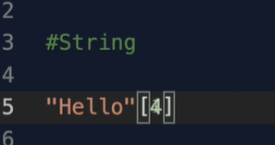

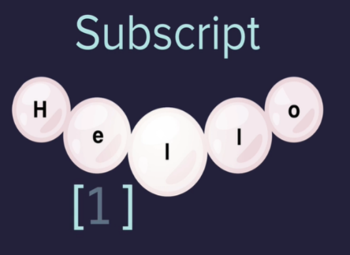

Cannot use , in large integers but can use an underscore

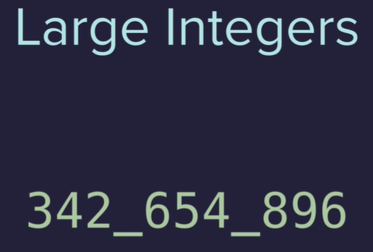

Float is a number with a decimal point   
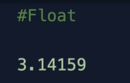

Boolean is just true or false

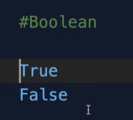

Functions

len will not work with integers

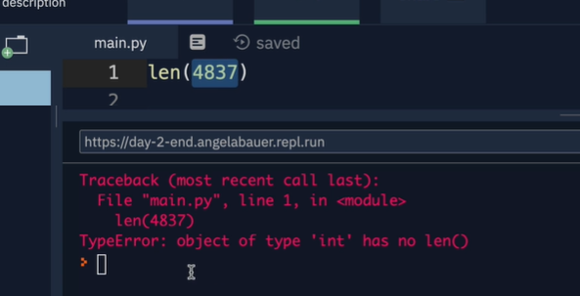

Concatenation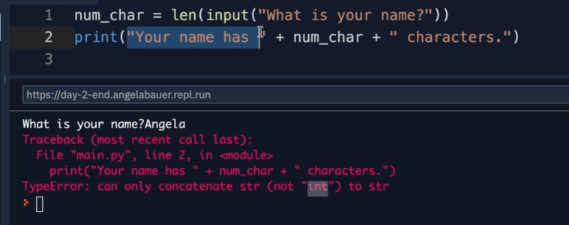

Can determine data type of something using the type function – type check function 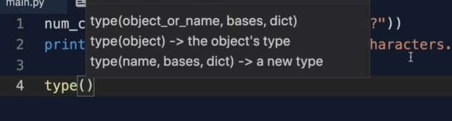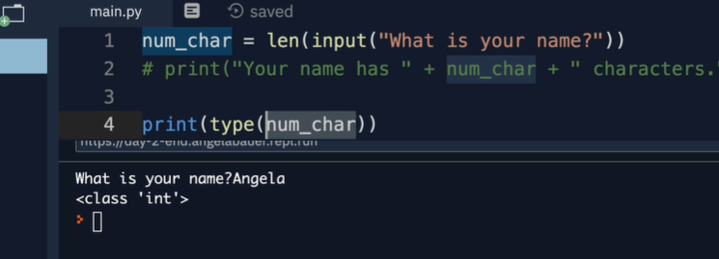

Type casting or type conversion make one data type to another make integer into string

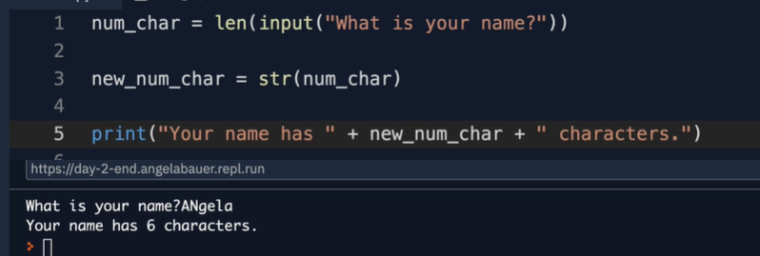

Math operations in python

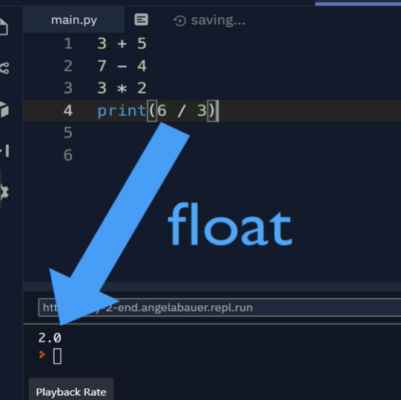

Exponent – this makes python good at math

\*\*

2\*\*2 = 4

2\*\*3 = 8

Level of priority

PEMDAS and left to right for a tie

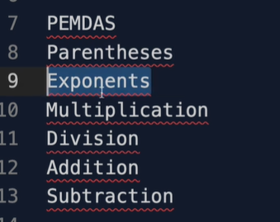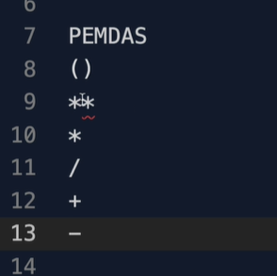

BMI calculator

Number manipulation and f string sin python

Round function

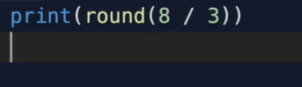

Can pass in a level of specificity in rounding too

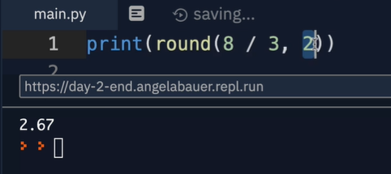

Floor division

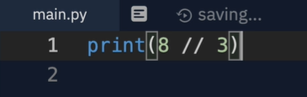

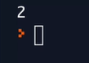

Type of integer

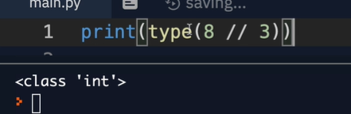

/=

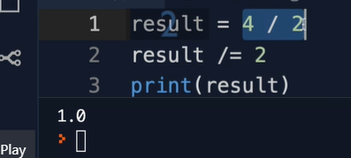

Also +=.-=,\*=

F strings – mixing strings and other data types

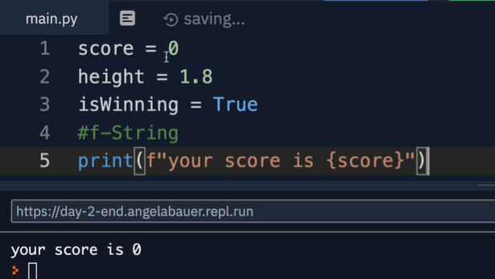

Interview question   
"Write a program that switches the values stored in the variables a and b."